**INTERNSHIP REPORT**

###### AN INTERNSHIP WITH APEX SILKS, BENGALURU

SUBMITTED IN PARTIAL FULFILLMENT OF THE REQUIREMENTS OF THE BACHELOR OF BUSINESS ADMINISTRATION DEGREE COURSE OF

BENGALURU CITY UNIVERSITY



###### BY

###### Shoaib khan

**REGISTRATION NO.**

**21**

UNDER THE GUIDANCE OF

**Mr. KARTHIK. N.L**

Assistant Professor

DEPARTMENT OF MANAGEMENT

**2023- 2024**



**Internship Certificate**

06/03/2024

Subject: Internship Certificate Letter

TO WHOM IT MAY CONCERN

This is to certify that **shoaib** bearing Code: DJ4052M has successfully completed an internship with **APEX SILKS** as and accounting Intern including GST practice in the Department GST from 15/01/2024 to 29/02/2024.3

She has worked on the financial accounting Project under the supervision and guidance of Mr. **Deepak Jangid** (AUDITOR). During the internship, she has gained several learnings such as data handling and developed considerable skills.

Besides showing high comprehension capacity, managing assignments with the utmost expertise, and exhibiting maximal efficiency, she has also maintained an outstanding professional demeanour and showcased excellent moral character throughout the internship period.

I hereby certify her overall work as excellent to the best of my knowledge.

Wishing her the best of luck in her future for endeavours.

Authorized Signatory

**EVALUATION OF INTERNSHIP REPORT**

**For Submission to Bengaluru City University**

|  |  |
| --- | --- |
| **Student** | **Mentor/Supervisor** |
| **Name: shoaib** | **Name: Mr. Kiran manjunath** |
| **Reg. No: 21** | **Signature:** |
| **Signature:** |
| **Date:** | **Date:** |

**Evaluation Summary**

|  |  |  |  |
| --- | --- | --- | --- |
|  | **Project Report** | **VIVA VOCE** | **Total** |
| **Maximum Marks** | **60** | **40** | **100** |
| **Marks Allotted** |  |  |  |
| **Name of Examiner:** | | **Signature:** | |

## CERTIFICATE

###### This is to certify that the Internship Report Titled “AN INTERNSHIP WITH APEX SILKS, BENGALURU” is carried out b shoaib student of VI Semester BBA, bearing Register No. 21under the Guidance of Mr. Kiran manjunath, Associate Professor, Department of Management. She has successfully completed her 4 Weeks organizational study. The student has attended the required guidance sessions held.

###### The Internship report is submitted to the Bengaluru City University in the Academic Year 2023-24, in partial fulfilment for successful completion of VI semester BBA and award of Business Administration Degree course of Bengaluru City University.

##### Prof. ] C M Head of the Department Principal

CERTIFICATE FROM THE GUIDE

This is to certify that the content of this report on “APEX SILKS carried out by shoaib student of VI semester BBA , bearing Register no 21 is a bonafide work carried out by the student under my supervision during the academic year 2023-24 in partial fulfilment for the completion of VI semester BBA Degree of Bengaluru City University.

This Internship report is original work carried out by the said student and there is no plagiarism. This Internship report has not been submitted for the award of any other degree / diploma in this institution or any other institution.

**PLACE: BANGALORE**

**DATE: SIGNATURE OF THE GUIDE**

**Kiran manjunath**

**DECLARATION BY THE STUDENT**

I hereby declare that this Internship report on “Organizational Study with particular reference to finance” is an original record of my experience while conducting the internship study at APEX SILKS.

The organizational study was carried out by me, in partial fulfilment for the successful completion of VI semester BBA Course of Bengaluru City University. This report is not submitted to any other university for the award of any Diploma/Degree etc.

###### DATE: NAME OF THE STUDENT

###### shoaib

###### PLACE:

**ACKNOWLEGMENT**

I deem it my privilege to thank **C.M, the Principal of the College,** and  **Coordinator ,** Department of Management studies and the faculty members for providing me with guidance and support for the successful completion of the internship report. I owe a deep sense of guidance to my internship report**Associate Professor** of the Department of Management, Jain College, for the guidance, cooperation and continuous support which have been vital for the completion of the internship report.

I will take pride and immense pleasure to express my gratitude to **Mr. DEEPAK JANGID** for granting me permission to do the internship report, and for their ample support, and valuable guidance that has enabled me to complete this internship.

I would like to extend my gratitude to my **Family and Friends** for providing me the resources, support, inspiration, and encouragement, necessary to complete the internship report.

I also want to thank all of those who have been involved directly or indirectly in the completion of the internship report.

**DIYA J MEHRA**

**LIST OF CONTENTS**

|  |  |  |
| --- | --- | --- |
| **CHAPTER**  **NO** | **CONTENT** | **Page No** |
| **1** | **INTRODUCTION** |  |
|  | **1.1 INDUSTRY** |  |
|  | **1.2 CONTRIBUTION TO THE GDP** |  |
|  | **1.3 IMPORTANCE OF INDUSTRY** |  |
|  | **1.4 INTERNSHIP OBJECTIVES** |  |
| **2** | **PROFILE OF THE ORGANISATION** |  |
|  | **2.1 COMPANY VISION** |  |
|  | **2.2 COMPANY MISSION** |  |
|  | **2.3 ORGANIZATION CHART** |  |
|  | **2.4 COMPANY SIZE** |  |
|  | **2.5 COMPANY REGISTERED OFFICE** |  |
|  | **2.6 COMPANY PRODUCT AND SERVICE LIST** |  |
|  | **2.7 COMPANY COMPETITORS** |  |
|  | **2.8 SWOT ANALYSIS** |  |
| **3** | **FUCTIONS AND OPERATIONS OF THE ORGANISATIONS** |  |
|  | **3.1 STEPS IN THE OPERATION OF APEX SILKS** |  |
|  | **3.2 NATURE OF THE TASK** |  |
|  | **3.3 OBJECTIVES, CONTEXT AND METHODOLOGIES USED TO COMPLETE THE TASK** |  |
|  | **3.4 PROBLEMS IDENTIFIED** |  |
| **4** | **LEARNINGS, OUTCOMES, SUGGESTIONS AND CONCLUSIONS** |  |
|  | **4.1 ESSENTIAL SKILL AND KNOWLEDGE GAINED** |  |
|  | **4.2 CONTRIBUTIONS** |  |
|  | **4.3 RELATION OF BBA COURSE WITH THE INTERNSHIP OBJECTIVES** |  |
|  | **4.4 CHALLENGES FACED** |  |
|  | **4.5 COMPANIES WORK ENVIRONMENT, CULTURE AND QORK PRACTICES** |  |
|  | **4.6 SUMMARY OF OVERALL EXPERIENCE** |  |
|  | **4.7 A NOTE TO THE INTERNS** |  |
| **5** | **BIBLIOGRAPHY** |  |
| **6** | **LOG SHEET** |  |

# Chapter - 1

# INTRODUCTION

* 1. **Introduction**

The industry I have completed my internship in belong to the textile industry, which is a broad sector encompassing the production and processing of fibers, yarns, fabrics, and finished textile products. More specifically, silk sarees are part of the apparel and fashion industry, given their role as a prominent and traditional form of clothing in various cultures, particularly in South Asia.

Apex Silks operates as a wholesaler and distributor of silk sarees, it plays a crucial role in the supply chain, bridging the gap between manufacturers and retailers or end consumers. Their role as a wholesaler, inventory management including the pricing is to be done. As an accounting intern in Apex silks, I gained hands-on experience in using certain software and enhancing my understanding of GST. I also developed my skills not only under the accounting field but also under sales as there should be a knowledge about the sales and purchase if data needs to be entered in the system and this helped in contributing to strategic decision-making processes.

By operating as a wholesaler and distributor, this company not only facilitates the availability of beautiful silk sarees to a wider audience but also supports the traditional weaving communities and ensures that high-quality, culturally significant garments continue to be cherished and worn. Their strategic approach to sourcing, inventory management, logistics, and customer relations has been crucial in maintaining and growing their position in the market.

* 1. **The textile industry has significantly contributed to the GDP of India through various channels.**

1. Economic Contribution

Major Contributor to GDP: The textile industry accounts for about 2-3% of India's GDP. It is one of the oldest industries in the country and plays a vital role in the economy.

Employment Generation: The sector is the second-largest employer in India after agriculture, providing jobs to over 45 million people directly and 60 million people indirectly, including a significant number of women and rural workers.

2. Export Earnings

Significant Exporter: The textile and apparel sector contributes approximately 12% to India's total export earnings. India is one of the largest exporters of textiles and apparel in the world, exporting to markets in the USA, EU, and the Middle East.

Foreign Exchange: The industry helps in earning substantial foreign exchange, thereby contributing to the country's foreign reserves.

3. Investment and Growth

Domestic Investment: Significant investments are made in the textile sector, both from private and public entities, driving economic growth and technological advancement.

FDI Attraction: The sector attracts considerable foreign direct investment (FDI), contributing to overall economic growth and the modernization of the industry.

4. Value Addition and Manufacturing

Diverse Segments: The industry encompasses a wide range of segments including cotton, silk, wool, and synthetic fibers, contributing to value addition across the manufacturing sector.

Rural Development: It supports rural development by providing employment and supporting small-scale industries and artisans involved in traditional textile crafts.

5. Government Initiatives

Policy Support: Government initiatives like the Textile Policy, Make in India, and Skill India have bolstered the industry's contribution to GDP by promoting investment, enhancing skills, and improving infrastructure.

6. Schemes and Subsidies: Schemes such as the Technology Upgradation Fund Scheme (TUFS) and subsidies for the apparel sector encourage modernization and efficiency, boosting productivity.

* 1. **The textile industry is immensely important to the economy, especially in a country like India**

1. Export Earnings

* Foreign Exchange: The industry is a major exporter of goods, contributing significantly to the country’s foreign exchange earnings. For example, in India, the textile and apparel sector contributes about 12% to total export earnings.
* Global Market Presence: Countries with strong textile industries often have a significant presence in global markets, exporting textiles and apparel to a wide range of countries.

1. Investment Attraction

* Domestic Investment: The industry attracts substantial domestic investment, which spurs economic growth and technological advancements.
* Foreign Direct Investment (FDI): It also attracts considerable foreign direct investment, further boosting economic development and modernization of the sector.

1. Support to Ancillary Industries

* Value Chain: The textile industry supports a wide range of ancillary industries such as agriculture (cotton farming), chemical (dyes and pigments), and machinery (textile machinery manufacturing).
* Small and Medium Enterprises (SMEs): It provides a foundation for numerous small and medium enterprises that are crucial for economic diversification and resilience.

1. Regional Development

* Infrastructure Development: The establishment of textile units often leads to the development of infrastructure in the surrounding areas, including transportation, warehousing, and utilities.
* Balanced Growth: It promotes balanced regional development by establishing industries in various parts of the country, including less developed regions.

1. Technological Advancement

* Innovation and R&D: The textile industry invests in research and development, leading to innovations in materials, production processes, and sustainable practices.
* Technological Upgradation: Adoption of new technologies enhances productivity, efficiency, and competitiveness of the industry.

1. Cultural Significance

* Cultural Heritage: In many countries, the textile industry preserves and promotes traditional crafts and cultural heritage, contributing to the cultural economy.
* Artisan Support: It supports artisans and traditional weavers, providing them with sustainable livelihoods and helping to keep traditional skills alive.

1. Sustainability and Environmental Initiatives

* Eco-Friendly Practices: The industry is increasingly adopting sustainable practices such as organic farming, water-efficient dyeing techniques, and recycling.
* Corporate Social Responsibility (CSR): Many textile companies are involved in CSR activities.
  1. **Internship objectives**

Being the intern of this textile industry, the internship objectives were:

1. To Gain Practical Accounting Experience
2. To have knowledge of Software and be proficient in it
3. Learn Cost Accounting
4. Learn to read Financial Reports and its Analysis
5. Prepare Financial Statements

By achieving these objectives, I could significantly contribute to the organization while also developed skills and knowledge for a future career in accounting.

# 

# CHAPTER-2

**PROFILE OF THE ORGANIZATION**

**2.1 Company Vision**



- Become the leading global distributor and wholesaler of premium silk sarees.

- Be renowned for exceptional quality and timeless designs.

- Implement and maintain sustainable practices.

- Preserve the rich heritage of silk weaving.

- Empower artisans.

**2.2 Company Mission**



To deliver high-quality silk sarees that celebrate tradition and innovation, ensuring customer satisfaction through superior service and product excellence. We aim to foster long-term relationships with our suppliers, customers, and partners, promoting sustainable practices and contributing positively to the communities we serve.

**2.3 Organization chart**

**2.4 Company size**

The company being a wholesaler and distributor of silk sarees requires staff members who would help in the managing of the sarees and packing the perfect ordered saree. Apex silks currently has around 20 people working which includes 7 staffs and 13 professional and has a turnover of around 5.8-6 Crore per year and the companies assets are valued at 2Crore (included 1.5 Crore stock)

**2.5 Company registered office**

Apex Silks is headquartered in Bangalore . Karnataka. The registered location is :

No.33, 2nd Floor, Gangappa Complex, Malikarjunappa Lane, K R City Pet, Avenue Road, Bangalore – 560002

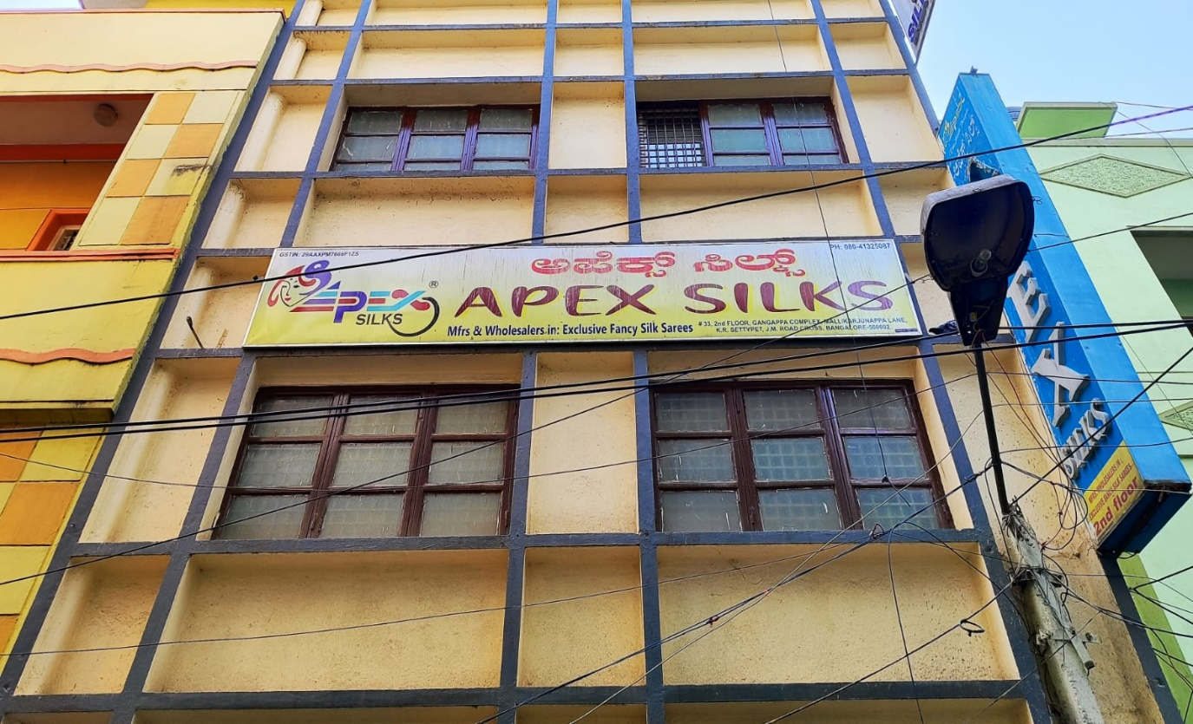

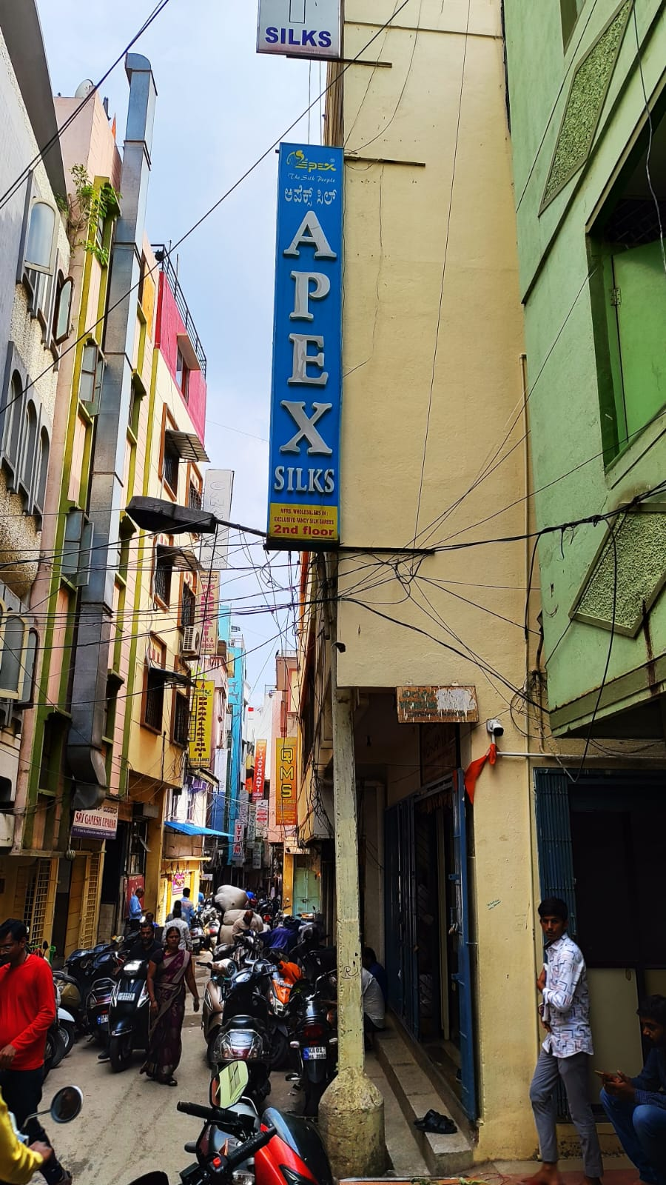

**2.6 Company product/service list**

At Apex Silks they are deeply rooted in the traditions of Indian textiles.

Each saree in their collection is a testament to the skill and dedication of their master weavers. They source their silk from the best producers, ensuring that every piece meets the highest standards of quality. their sarees feature intricate designs, vibrant colors, and luxurious textures, making them perfect for every occasion. From traditional Banarasi and Kanjeevaram to contemporary designer sarees, our range caters to diverse tastes and preferences.

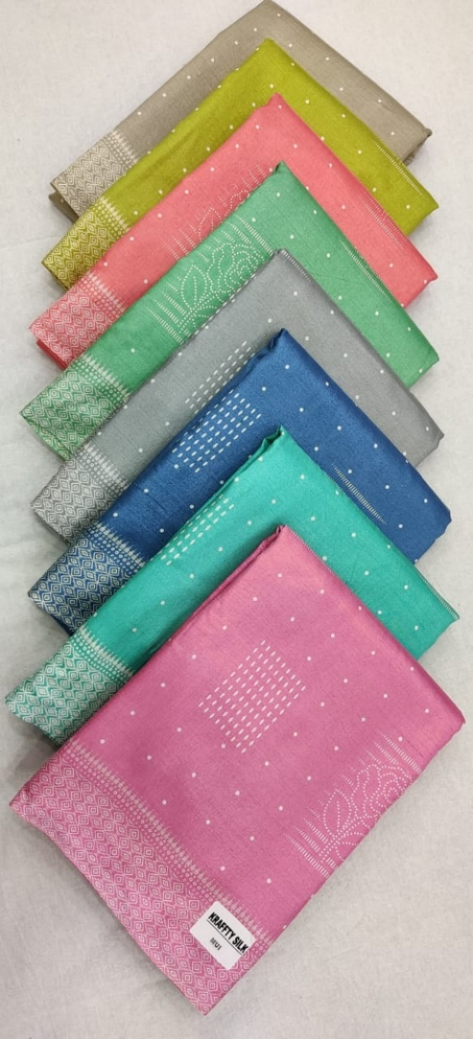

[C×C kartika print]

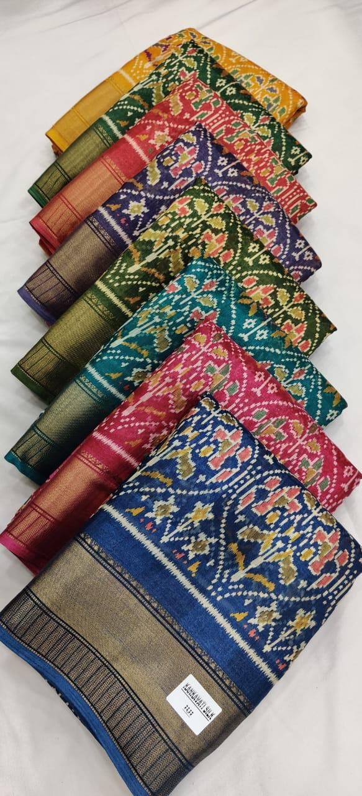

[Linen digital print]

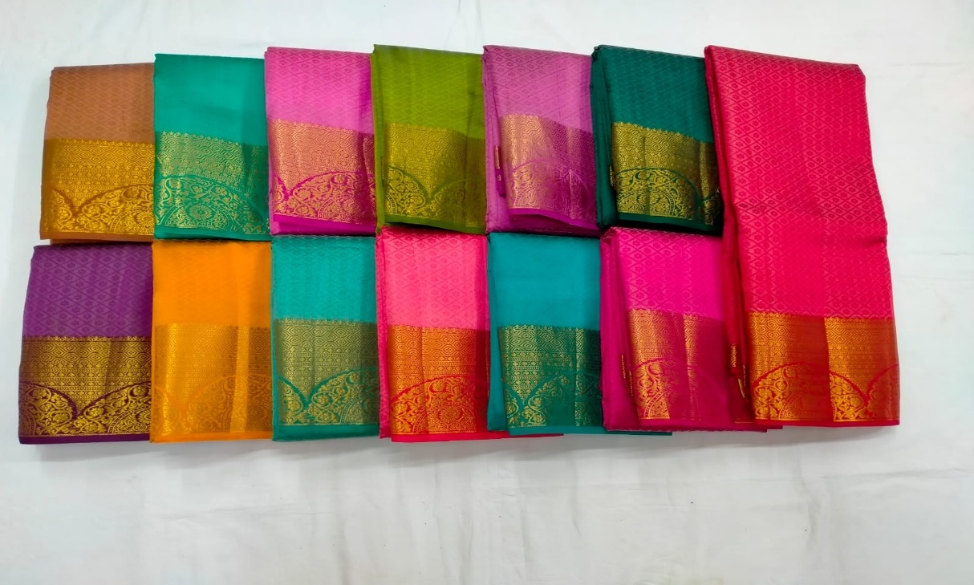

[Tusser kanjivaram embose]

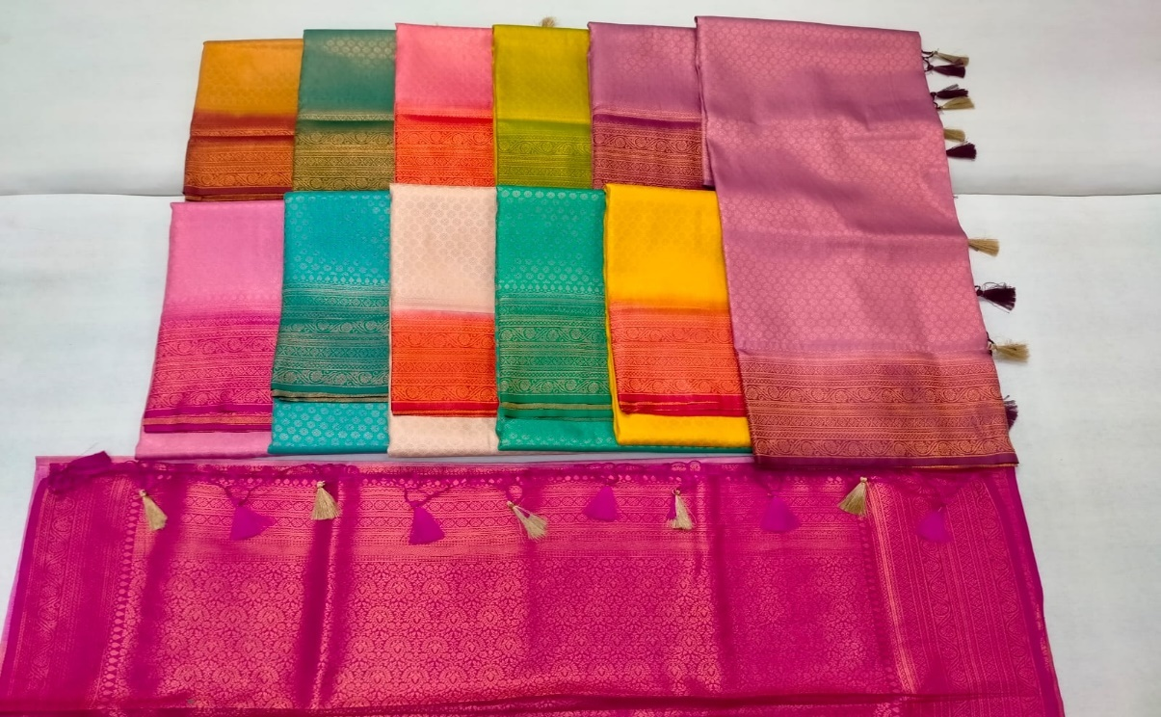

[Soft shaded print]

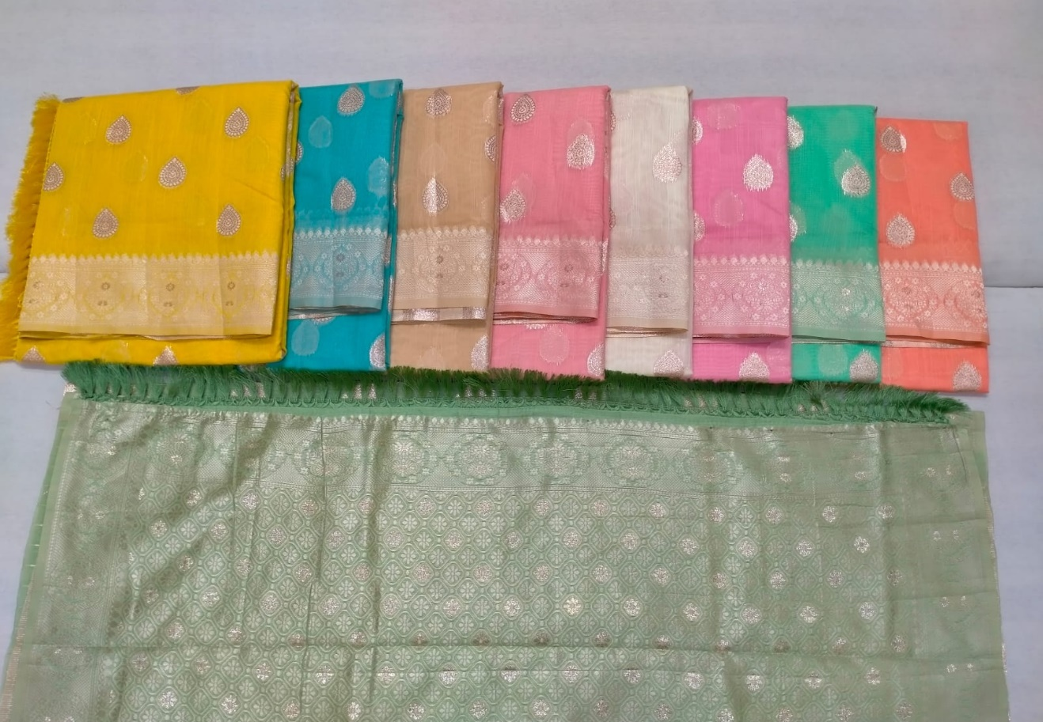

[HL cotton]

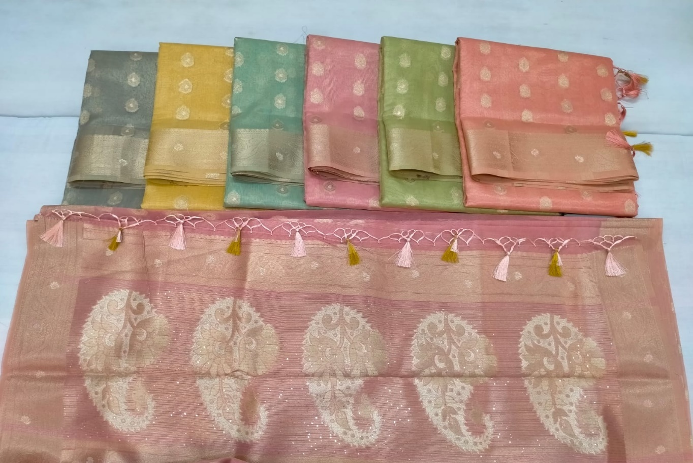

[Tissue broket]

Their Collection

Their extensive collection includes:

1. -Banarasi Silk Sarees: Known for their opulent zari work and intricate patterns, these sarees are a symbol of grandeur.
2. Kanjeevaram Silk Sarees: Renowned for their durability and vibrant colors, these sarees are a favorite for weddings and special occasions.
3. Tussar Silk Sarees: Featuring a unique texture and natural gold sheen, these sarees are perfect for both casual and formal wear.
4. Designer Silk Sarees: Blending traditional techniques with modern designs, these sarees offer a contemporary twist to classic elegance.
5. Mysore silk sarees: Patola sarees are double ikat woven silk sarees known for their geometric patterns and vibrant colors. The weaving process is extremely intricate and time-consuming.
6. Chettinad silk saree: Known for their bold colors and contrasting borders, Chettinad sarees typically feature checks, stripes, and temple borders. The designs are often simple yet striking, with an emphasis on traditional motifs.
7. Konrad silk: Also known as temple sarees, Konrad silk sarees feature wide borders with traditional motifs like elephants and peacocks. They are usually made in earthy tones.
8. Patola silk saree : Patola sarees are double ikat woven silk sarees known for their geometric patterns and vibrant colors. The weaving process is extremely intricate and time-consuming.

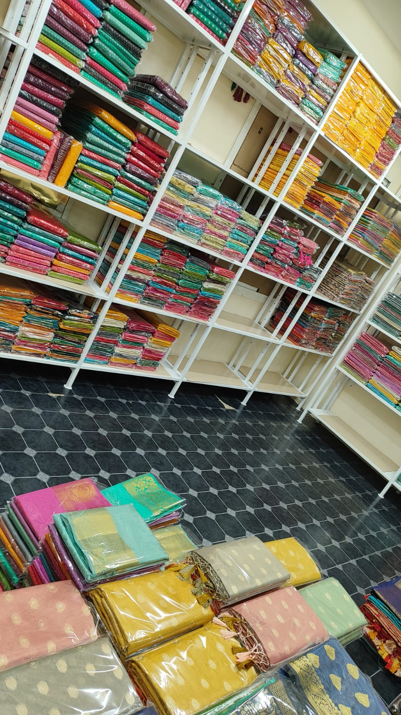

[Stock arranged according to the requirements]

**2.7 Company competitors**

1. Anmol silks
2. Rukmini Silks
3. Surekha designs
4. MS silks
5. Mannat tax

**2.9 SWOT analysis of the company**

STRENGTHS:

* High-Quality Product Offering.
* Established relationships with weavers and suppliers ensure a steady supply of diverse and high-quality silk sarees.
* Brand Reputation
* Wide Distribution Network

.

WEAKNESSES:

* High Inventory Costs
* Demand for silk sarees can be highly seasonal, peaking during wedding and festival seasons, leading to fluctuating sales.
* Quality Control Issues
* Limited Product Range i.e., Focusing solely on silk sarees may limit market reach compared to competitors offering a broader range of apparel.

OPPERTUNITIES:

* E-commerce Expansion.
* Growing Demand for Ethnic Wear
* Product Diversification
* Emphasizing sustainable and eco-friendly production practices can attract environmentally conscious consumers.

THREATS:

* Intense competition from other silk saree distributors, wholesalers, and retailers can impact market share.
* Economic Downturns
* Changing Fashion Trends: Rapid changes in fashion trends can lead to a decline in demand for traditional silk sarees.
* Supply Chain Disruptions

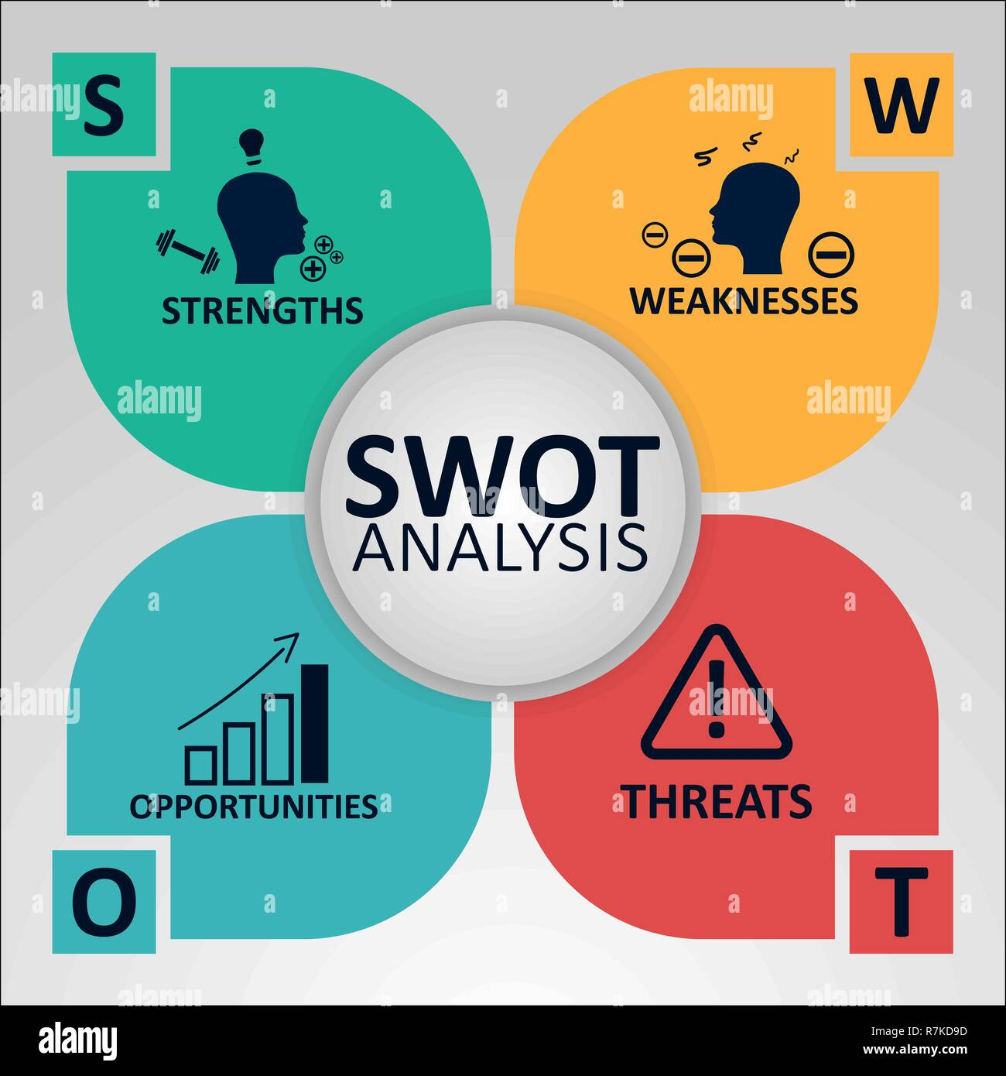

|  |  |
| --- | --- |
| Strengths   * High-Quality Product Offering * Cultural Relevance * Brand Reputation * Wide Distribution Network | Weaknesses   * High Inventory Costs * Seasonal Demand * Quality Control Issues * Limited Product Range |
| Opportunities   * E-commerce Expansion. * Growing Demand for Ethnic Wear * Product Diversification * Sustainable Practices. | Threats   * Market Competition. * Economic Downturns * Fluctuating Raw Material Prices * Changing Fashion Trends. * Supply Chain Disruptions |

**CHAPTER-3**

**FUNCTIONS AND OPERATIONS OF THE ORGANIZATION**

**3.1 Steps in the Operation of Apex Silks**

1. Market Research and Planning:

* Identify Market Demand and understand customer preferences, seasonal trends, and demand for different types of silk sarees.
* Business Planning: Develop a strategic business plan outlining goals, target markets, marketing strategies, and financial projections.

2. Supplier Sourcing and Procurement

* Select Suppliers: Identify and evaluate potential suppliers and weavers based on quality, reliability, and cost.
* Negotiation: Negotiate terms of supply, including pricing, payment terms, delivery schedules, and quality standards.
* Place Orders: Place bulk orders with selected suppliers to ensure a steady supply of high-quality silk sarees.

3. Quality Control

* Inspection: Inspect sarees upon receipt to ensure they meet the quality standards and specifications agreed upon with suppliers.

4. Inventory Management

* Warehouse Management: Organize and manage warehouse space to store inventory efficiently and securely.
* Inventory Tracking: Implement inventory management systems to track stock levels, sales, and reorder points.

5. Sales and Marketing

* Build a Sales Network: Establish relationships with retailers, boutiques, and other potential buyers.

6. Order Processing and Fulfillment

* Receive Orders: Process orders received from retailers, boutiques, and customers.
* Prepare Shipments: Pack and prepare orders for shipment, ensuring they are securely packaged to prevent damage.

7. Customer Service and Relationship Management

* Customer Support: Provide pre-sales and post-sales support to address inquiries, complaints, and returns.
* Maintain Relationships: Build and maintain strong relationships with key customers through regular communication and personalized service.

8. Financial Management

* Budgeting and Planning: Prepare and manage budgets to control costs and maximize profitability.
* Invoicing and Collections: Generate invoices and ensure timely collection of payments from customers.
* Financial Reporting: Keep accurate financial records and generate reports to monitor business performance and inform decision-making.

**3.2 The nature of the task I was assigned**

During my internship in the company of Apex Silks Sarees, I was given the role of a financial accounting and GST auditing intern. I had been given the task of data entry, financial management and to have the overall practical experience.

**3.3 The context, objectives and methodologies used to complete the task**

|  |  |
| --- | --- |
| **Financial Analysis and Reporting** | 1. **Sales Analysis**   **Method**: Used spreadsheet software (Excel)  **Objective:** To visualize trends and to compile and analyze sales data. |
| **Accounts Payable and Receivables** | 1. **Invoice Preparation**   **Method:** Review invoices, match with purchase orders and receive the report.  **Objectives:** Done to check the accuracy   1. **Statement Reconciliation**   Compare payments received against outstanding invoices and update records.   1. **Vendor Management:**   **Method: Maintain** a schedule of payments, track due dates, and ensure timely payments.  **Objective:** Build and maintain effective relationships with vendors. Develop negotiation and communication skills. |
| **Inventory Management** | 1. **Stock Audit**   **Method:** Conduct physical counts, compare with system records, and investigate discrepancies.  **Objective:** Ensure accuracy of inventory records. Develop skills in auditing and inventory management. |
| **Financial Compliance and Documentation** | 1. **Organizing the financial statements**   **Method:** Organize financial documents systematically, ensure accurate filing, and maintain both digital and physical copies  **Objective:** Maintain organized and accessible financial records. Learn best practices in documentation and compliance.. |
| **Financial Software and System** | 1. **System updates**   **Method**: Regularly update financial software, ensure data backups, and troubleshoot issues  **Objective:** Learn about financial software.   1. **Data Entry:**   **Method:** Accurately enter financial data into accounting systems, ensuring double-checking for errors.  **Objective:** Ensure accurate and timely entry of financial data. Develop data entry and accuracy skills |
| **Special Projects** | 1. **Market Research:**   **Method:** Collect and analyze data on market trends, competitor pricing, and customer preferences.  **Objective**: Provide insights into market trends and competitor strategies. Develop research and analytical skills. |
| **Learning And Development** | 1. **Decision Making Process**   **Method:** Observe and assist senior finance team members in their daily tasks to gain practical insights.  **Objective:** Gain practical insights and hands-on experience |

* 1. **Problems identified**

Certain problems and challenges we’re identified by me . those include,

1. Errors in data entry affecting financial accuracy
2. Lack of in-depth knowledge
3. Lack of Stress management

# 

**CHAPTER-4**

**LEARNING OUTCOMES, SUGGESTIONS AND CONCLUSIONS**

* 1. **Essential skills and knowledge gained while completing the task**

1. **Practical Application of theoretical knowledge:**

Understand the importance of accurate documentation and regulatory compliance in financial operations. Learn best practices in maintaining organized financial records and preparing for audits.

1. **Development of professional skills**

Learn to identify and solve real-world financial problems, such as discrepancies in reconciliation and compliance issues.

Develop critical thinking and decision-making skills. Improve technical skills in using financial software and tools (e.g., Excel, QuickBooks, SAP).

1. **Exploration of career paths:**

Exploring career paths within the finance department of a wholesaler and distributor of silk sarees offers a range of opportunities for professional growth and development. Implementing professional development strategies, individuals can navigate their career progression within the finance department of a wholesaler and distributor of silk sarees, achieving both personal and professional growth.

* 1. **My contribution in Apex Silks that helped the organization**

1. Improve relationships with vendors and customers through timely communication and resolution of billing issues.
2. Provided support in conducting stock audits and maintaining accurate inventory records,

Improved Inventory Management:

1. Provided support in conducting stock audits and maintaining accurate inventory recordsthat helped in improved inventory management
2. I was able to make more informed financial decisions.
3. Successfully completed specific projects or initiatives assigned to me ,contributing to the company’s goals and objectives.
4. Strengthen team dynamics by knowing and getting into the finance department, was encouraged and had shared knowledge
   1. **Relation of BBA course with internship objectives**
5. Practical Experience and Skill Development:

Gained hands-on experience, enhancing the technical and analytical skills

Industry Knowledge and Professional Growth:

1. Understood business functions and acquired industry-specific knowledge and gain insights into career paths in finance.
2. Problem-Solving and Decision-Making Abilities

Develop problem-solving skills through real-world financial challenges and decision-making tasks.

1. Communication and Interpersonal Skills:

Improved communication skills and learned to work effectively within a team.

1. Ethical and Compliance Awareness:

Ensured compliance with financial regulations and maintain ethical standards in documentation and reporting.

1. Technological and Software Proficiency:

Became proficient in financial software and tools essential for modern business operations.

* 1. **The challenges I faced during my internship include**

1. Limited Industry Knowledge the silk saree industry and market trends.
2. Dealing with the pressure of handling multiple tasks, and producing accurate results lead to stress.
3. Understanding Complex Financial Regulation:
4. Effectively communicating with customers, vendors, and colleagues can be challenging, especially in a professional setting.
5. Ensuring accuracy in data entry, financial reporting, and compliance documentation can be challenging and time-consuming.
   1. **The companies work environment, culture and work practices**



This involved fostered atmosphere that supported productivity, collaboration, and continuous improvement. Here are the key aspects:

1. Encouragement of Teamwork: They fostered a workspace where team members were encouraged to collaborate, share ideas, and work together on projects.
2. Open Communication: They maintained open lines of communication between all levels of the organization to ensure that everyone is informed and involved in decision-making processes.
3. Modern Tools: The financial department was equipped with up-to-date financial software and tools to enhance productivity and accuracy.
4. Comfortable Workspaces: Ensured that the physical workspace is comfortable, with adequate lighting, ergonomic furniture, and quiet areas for focused work.
5. Integrity: Embed a culture of integrity where honesty and ethical behavior are paramount.
6. Respect and Diversity: Fostered a culture of respect and inclusivity, valued diversity in all its forms.
   1. **Summary of overall experience and its impact on professional development**

Interning in the finance department of a wholesaler and distributor of silk sarees provides a comprehensive and enriching experience. It helped me engage in a variety of financial tasks, gaining hands-on experience that bridged the gap between academic learning and professional practice. The role involved significant responsibilities such as sales analysis, cost management, budgeting, and financial reporting, all of which contribute to a deeper understanding of financial operations within the specific context of the silk saree industry.

The internship offered a transformative experience, providing me with a solid foundation in financial operations and industry-specific practices. Through practical tasks, professional interactions, and exposure to the silk saree market, I developed a robust set of skills and a deeper understanding of the finance sector. This experience not only prepared me for immediate job opportunities but also sets the stage for long-term career success in finance. The combination of practical experience and professional development ensured that I am well-equipped to navigate and excel in the dynamic field of finance.

* 1. **For interns who would consider joining Apex Silks**

For interns considering to join with Apex Silks, the internship experience provides a solid foundation for a successful career in finance. The comprehensive learning environment, supportive culture, and clear career advancement opportunities make this organization an attractive choice for aspiring finance professionals. By joining the company, interns can continue to develop their skills, gain specialized industry knowledge, and grow within a dynamic and forward-thinking organization.

Certain recommendations for Apex Silks:

1. Have a good marketing strategies:

The company has not been digitally marketed and that becomes a drawback. A good marketing strategy would attract the potential retailers.

1. Adopt Flexible Working Conditions:

Consider implementing flexible working hours and remote work options where feasible, and ensure the necessary technology and support systems are in place.

1. Streamline Inventory Management:

Implement an inventory management system that integrates with the financial system to track inventory levels, forecast demand, and manage reorder points.

STATUS: INDIVIDUAL ASSESSMENT YEAR:2023-24

P.A. No: AAXPM7666F SRI JAGDISH KHATRI

DOB:30.6.1987

BALANCE SHEET AS ON 31.03.2023

|  |  |  |  |
| --- | --- | --- | --- |
| CAPITAL ACCOUNT | 51,06,570.46 | CASH IN HAND |  |
| BANK LOAN ACCOUNT | 35,814.66 | UNION BANK OF INDIA | 6,08,996.49 |
|  |  |  | 19,77,177.42 |
| LOAN CREDITORS | 2,43,62,086.93 | HDFC BANK C/A | 5,08,434.19 |
| SUNDRYTRADE CREDITORS | 2,60,15,978.74 | HDFC BANK SB | 2,11,102.19 |
| OUTSTANDING LIABILITIES | 4,64,199.00 | UNION BANK OF INDIA | 22,548.54 |
|  |  | DEPOSITS | 1,86,64,186.35 |
|  |  | INVESTMENT IN GOLD | 1,54,729.00 |
|  |  | SUNDRY DEBTORS | 2,69,04,179.31 |
|  |  | STOCK IN HAND | 57,68,966.00 |
|  |  | FIXED ASSETS | 11,64,330.30 |
| total | 55984649.79 |  | 55984649.79 |

**Bibliography**:

1. Just Dial

https://www.justdial.com/Bangalore/APEX-Silks-Avenue-Road/080P5146641_BZDET

1. indiaMART

https://m.indiamart.com/company/143379983/

**Application for internship**

|  |  |  |
| --- | --- | --- |
|  | Name of candidate ( in blocked letters) |  |
|  | Gender |  |
|  | Programme and year/Semester in which studying | FINAL YEAR/6TH SEMESTER  BBA |
|  | Email ID of the student Phone no./ Mobile no. |  |
|  | Name of Supervisor | Deepak Jangid |
|  | Email ID and contact number of supervisor |  |
|  | Name and address of the institution |  |
|  | Email ID and contact number of the institution |  |
|  | Complete permanent address of the student |  |
|  | Present mail address of the student |  |
|  | Address and the person to be contacted in case of emergency along with the phone number |  |

**DATE: SIGNATURE OF STUDENT:**

**RECCOMENDATIONS OF HEAD OF DEPARTMENT :**